Extramural Trainee Reporting and Career Tracking (xTRACT) Version1.3.0.0
Release Notes

New Features

Subsequent Grants Updated for Trainee or Student when Training End Date is Entered
Now when a training end date is entered in the End Date (when Trainee Left Program) field on the Participating Trainee Detail screen for a participating trainee or student, the subsequent grants for that trainee or student are prepopulated from available NIH sources provided that no subsequent grants were previously entered for that trainee or student for that particular Research Training Dataset (RTD).

Added Feature for Uploading Non-NIH Funding Sources is now Available
There is now a new feature in xTRACT for uploading non-NIH funding sources. It is accessed by clicking the Institution Data tab and clicking on the Upload Funding Sources hyperlink.

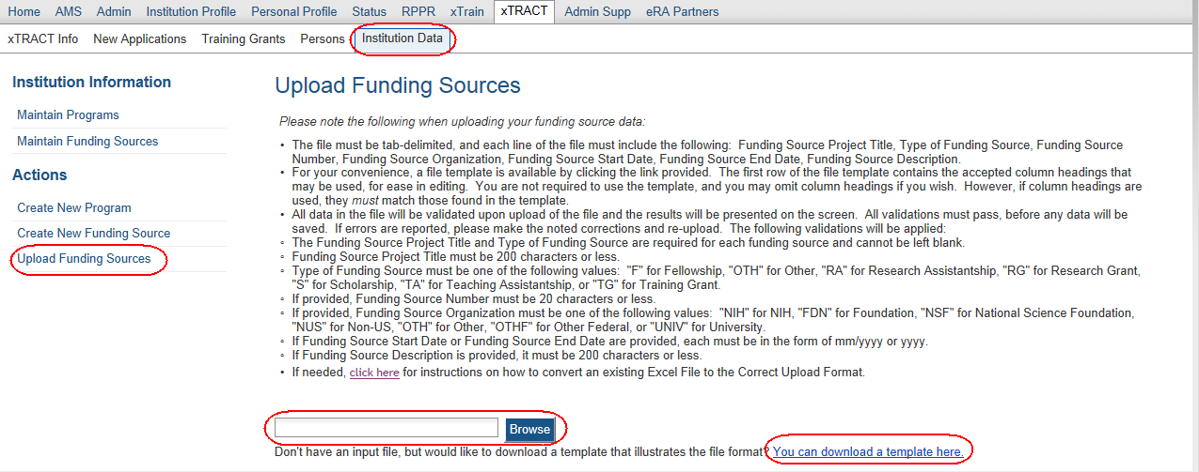
Figure 1: Upload Funding Sources Screen
NOTE: There are bulleted instructions for uploading the non-NIH funding source.

Fixes

Commons User ID now Displaying in Participating Trainees List
Previously the Commons User ID was not always displaying in the Participating Trainees list for a Research Performance Progress Report’s (RPPR) RTD.
This issue has been resolved.

Non-NIH Sources of Support now Displaying Correctly in Preview PDF
Previously the non-NIH sources of support were being displayed incorrectly in the PDF when the Preview PDF hyperlink was clicked in xTRACT. These sources of support applied to any non-NIH sources of support under the Summary of Support During Training in the following tables:
- Table 8A – Program Outcomes: Predoctoral
- Table 8C – Program Outcomes: Postdoctoral
This issue has been resolved. The correct abbreviations listed below now display:
- NSF
- Other Fed
- Univ
- Fdn
- Non-US
- Other

Training Grant Search now Displaying Type 5 Grants Correctly
Previously when a Type 2 (competing renewal) grant application had been submitted and its status was Pending Review, the previously awarded Type 5 in the grant family was not appearing in the search results on the Search for Training Grants screen. Consequently, if a user wished to start preparing for a resubmission of the competing renewal, there was no way to do so in xTRACT.
This issue has been resolved. In this scenario, the preceding awarded Type 5 grant is now returned in the search results on the Search for Grants screen.

OTH Degree Text is now Displaying in the Training Table PDF
If a faculty member or trainee/student received an OTH (Other) type of degree, it is required to enter what type of degree was earned in the Other Degree Text field on various screens in xTRACT. This Other Degree Text was not being displayed where appropriate in the Training table PDF.
This issue has been resolved. The Other Degree Text applies to any degrees listed in the following tables:
- Table 8A – Program Outcomes: Predoctoral
  - Sections: Terminal Degree(s) received and Year(s)
- Table 8C – Program Outcomes: Postdoctoral
  - Sections: Doctoral Degree(s) and Year(s) or Degree(s) resulting from Postdoctoral training and Year(s)

Doctoral Degrees now Appearing in Training Table 8C
Previously doctoral degrees were not appearing in the column labeled Doctoral Degree(s) and Year(s) in Table 8C whenever the doctoral degree earned date and the postdoctoral trainee’s entry program date were in the same month and year.
This issue has been resolved.

When Performing Training Grant Searches Assistants can now See all of their PIs
When performing training grant searches Assistants were not always seeing all of their Principal Investigators (PIs) as expected in their Delegator List in xTRACT.
This issue has been resolved.

