Purpose of this Document

Reviewers can use this quick start guide to learn how to locate the confidentiality statement, pre-meeting conflict of interest, critique templates, access code for a ZIP of templates and more in the Internet Assisted Review (IAR) module.

Handy Tip: The three-dot ellipsis is the key to accessing action items and key documents.

Locate the Confidentiality Statement
Use the three-dot ellipsis icon in the Meeting column to access the confidentiality statement on the List of Meetings screen.
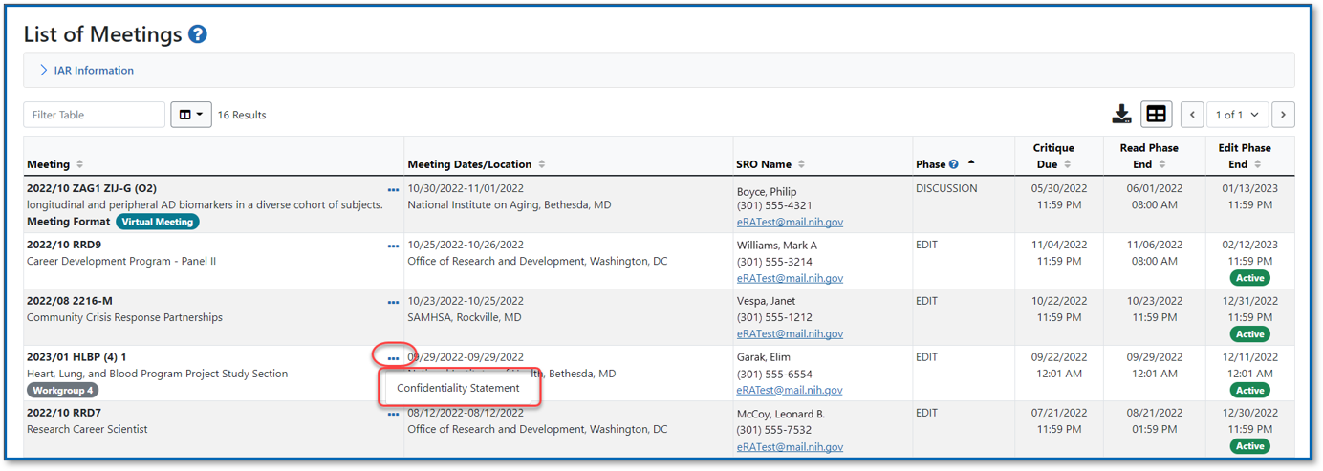
Figure 1: The Confidentiality Statement is accessed via the three-dot ellipsis on the List of Meetings screen
Check Conflicts (Recruitment Phase)
Once the confidentiality statement has been certified, for reviewers in the Recruitment Phase, the three-dot ellipsis will now provide the option to ‘Check Conflicts.’
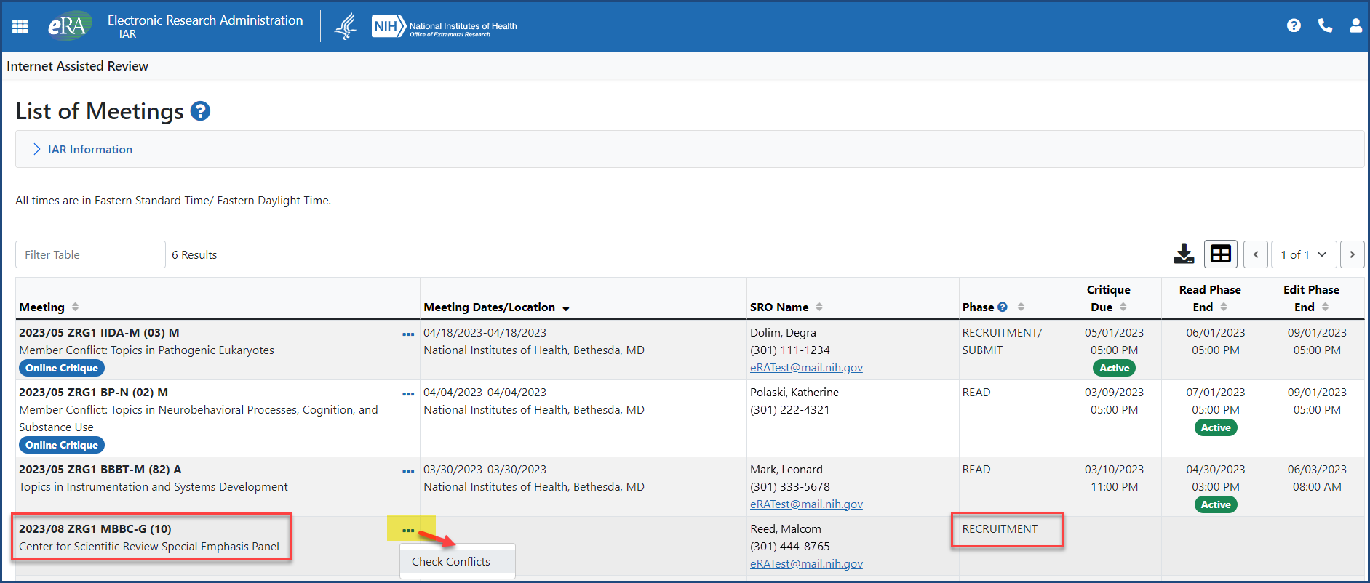
Figure 2: Once the confidentiality statement is certified, reviewers in the Recruitment Phase can access Check Conflicts via the three-dot ellipsis on the List of Meetings screen

Locate the Pre-Meeting COI
Once the confidentiality statement has been certified, the menu options from the three-dot ellipsis will update. Click the ellipsis to access the Pre-Meeting Conflict of Interest (COI) form from the updated menu.
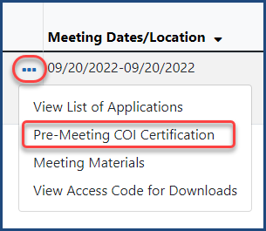
Figure 3: The Pre-Meeting COI certification is accessed via the three-dot ellipsis on the List of Meetings screen

Access the Application(s)
On the List of Meetings screen, click on the Grant Folder icon (see below) and you will be taken to the Application Folder screen (also known as Grant Folder).
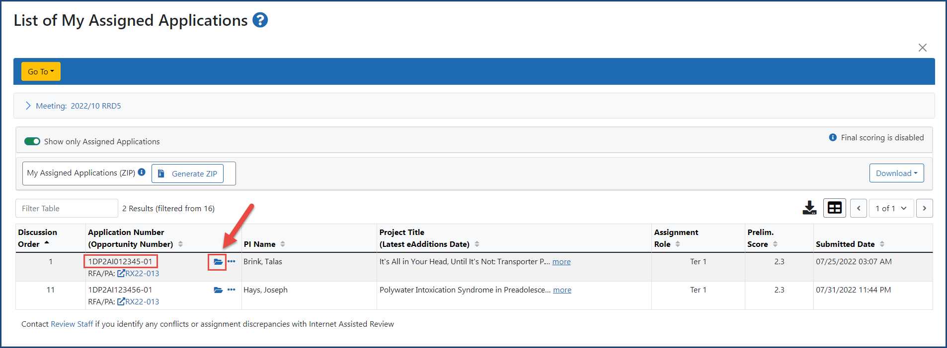
Figure 4: Click on the Grant Folder icon on the List of My Assigned Applications screen

On the Application Folder screen, click on the e-Application link to access the application.
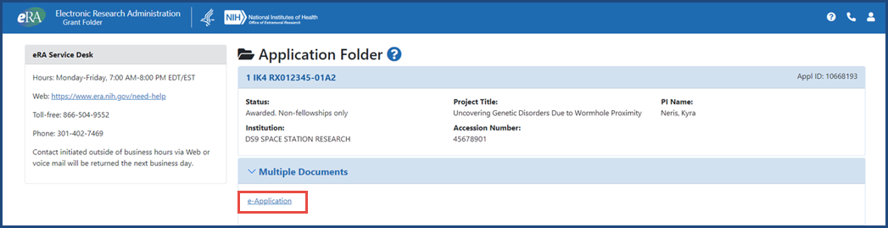
Figure 5: Click on the e-Application link to access the application

Access Critique(s)
On the List of Meetings screen, click on the three-dot ellipsis and select Meeting Materials.
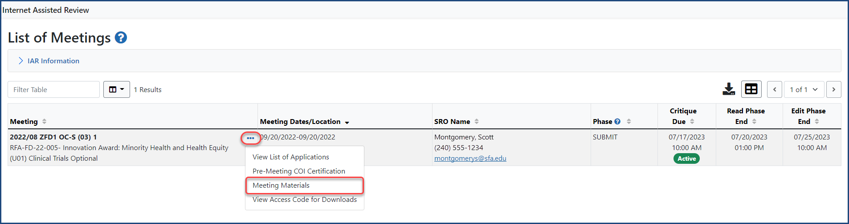
Figure 6: The Meeting Materials screen is accessed via the three-dot ellipsis on the List of Meetings screen
Or click on the Go To menu from the List of Meetings screen and select Meeting Materials
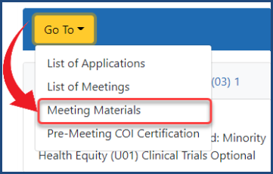
Figure 7: The Meeting Materials screen is also accessed via the Go To menu on the List of Meetings screen
Access the critique template from the Meeting Materials screen if the meeting is using Word-based critiques and the scientific review officer (SRO) has associated the template(s) with applications in Meeting Materials. Or download a ZIP of meeting materials.
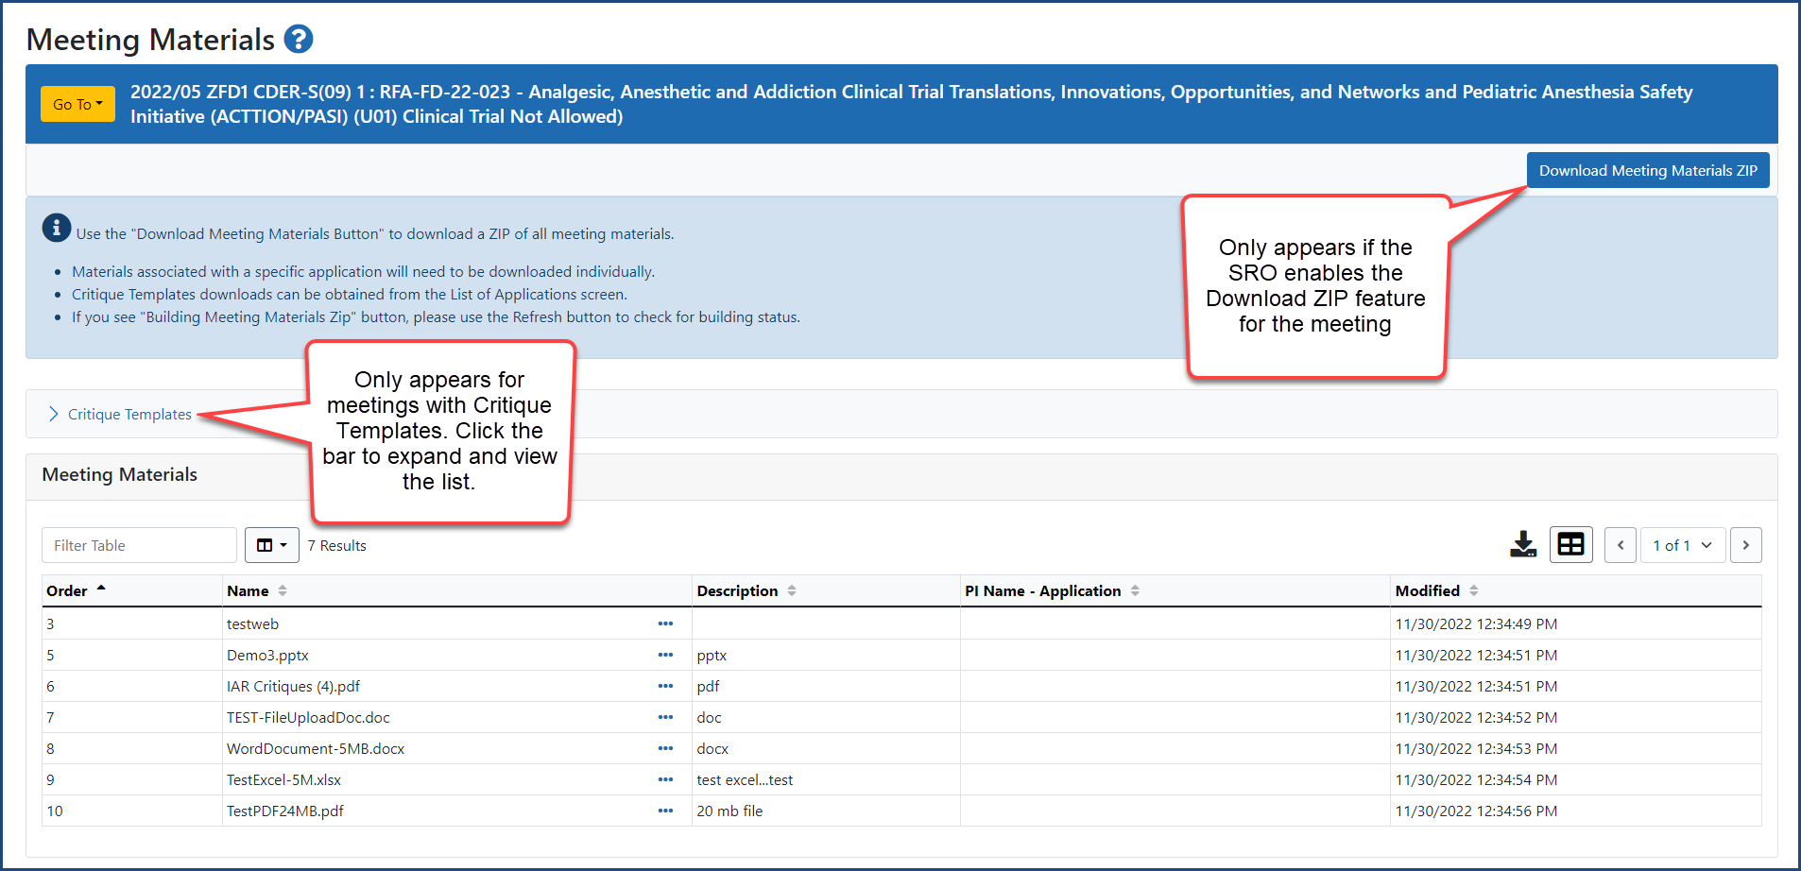
Figure 8: The critique template and the Download Meeting Materials ZIP are accessed from the Meeting Materials screen

View Access Code to Download ZIP
Reviewers need an access code, set by the SRO in IAR, to download the ZIP file of meeting materials and their assigned applications from IAR. Go to the Meeting column on the List of Meetings screen, click on the three-dot ellipsis icon and select View Access Code for Downloads.
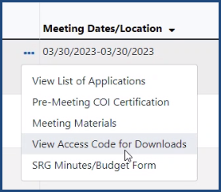
Figure 9: The View Access Code for Downloads link, accessed by clicking the ellipsis in the Meeting Column on the List of Meetings Screen
Go to Submit Critique Screen
On the List of My Assigned Applications screen, click the three-dot ellipsis in the Application Number column and select Submit Critique from the dropdown menu to be taken to that screen.
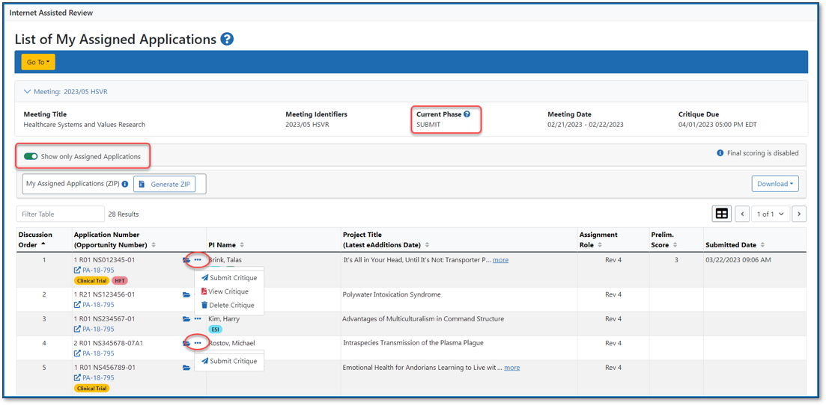
Figure 10: Click the ellipsis and select Submit Critique on the List of My Assigned Applications screen
View All Critiques
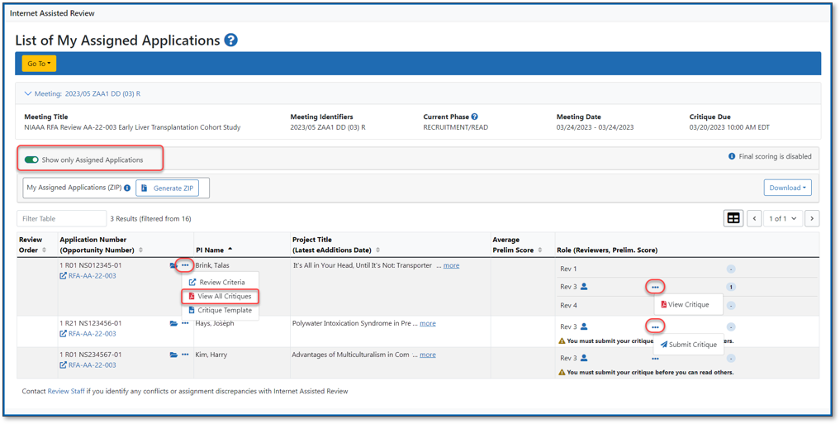
Figure 11: Click the ellipsis and select View All Critiques on the List of My Assigned Applications screen
View and Edit a Critique
During the edit phase, reviewers can update their critique. Click on the three-dot ellipsis and click on Update Critique.
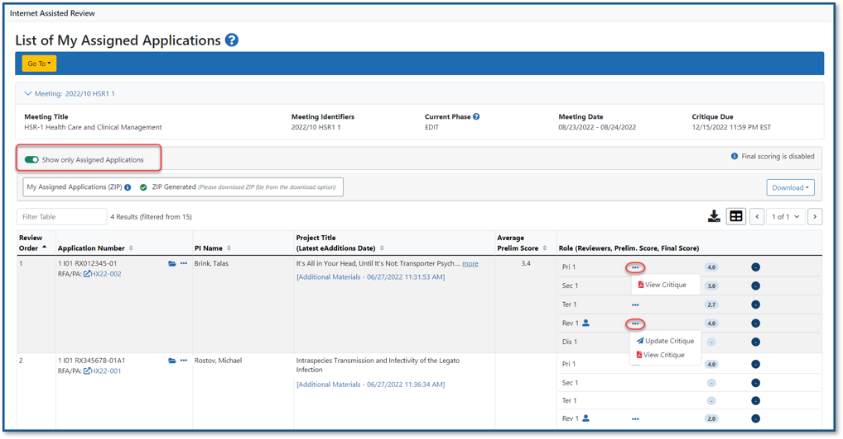
Figure 12: Click the ellipsis and select Update Critique on the List of My Assigned Applications screen
Final Scoring
Until final scoring starts, a message ‘Final scoring is disabled’ will appear on the List of Applications screen. When final scoring begins, a button will be displayed with the text ‘Final scoring is enabled.’
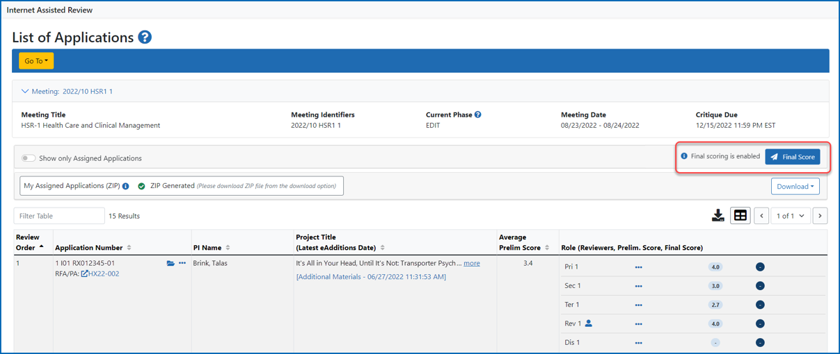
Figure 13: Final scoring is enabled message on the List of Applications screen

