Crosswalk: Inclusion Management System (IMS) and the New Human Subjects System (HSS) — for PIs and SOs

Topic | IMS (retired June 9, 2018) | HSS (replaced IMS on June 9, 2018)
Access
 | Accessed via Inclusion link in Section G.4.b of the RPPR in eRA Commons  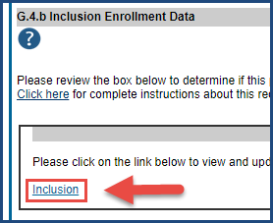 | Access via Human Subjects link in Section G.4.b of RPPR in eRA Commons  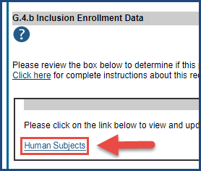
 | Accessed via Inclusion link in Status in eRA Commons  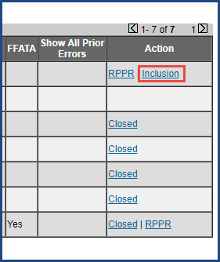  For SO: On the Status Result: General Search screen  For PI: On the Status Result-List of Applications/Awards screen  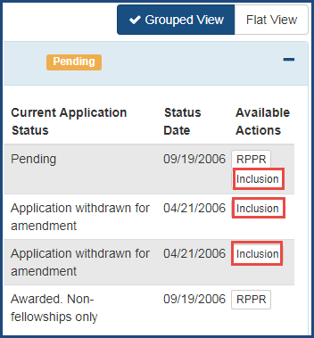 | Access via Human Subjects link in Status in eRA Commons  For SO: On the Status Result: General Search screen  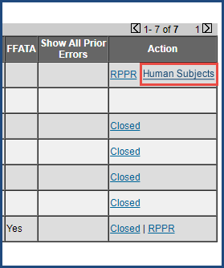  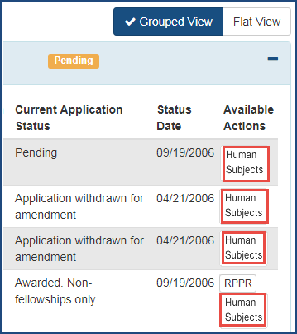  For PI: On the Status Result-List of Applications/Awards screen
Landing Screen | (Once you clicked on the Inclusion link) | (Once you click on the Human Subjects link)
 | Inclusion – Manage Inclusion Data Records (IDRs) screen  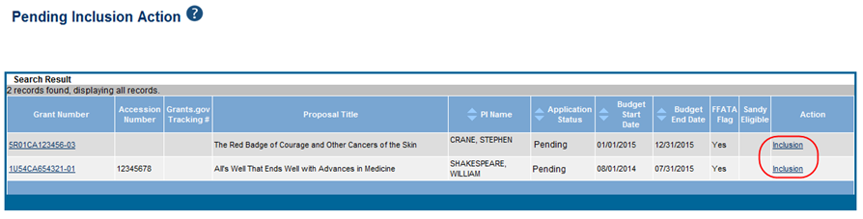 | Application Information screen, showing basic  information about your grant  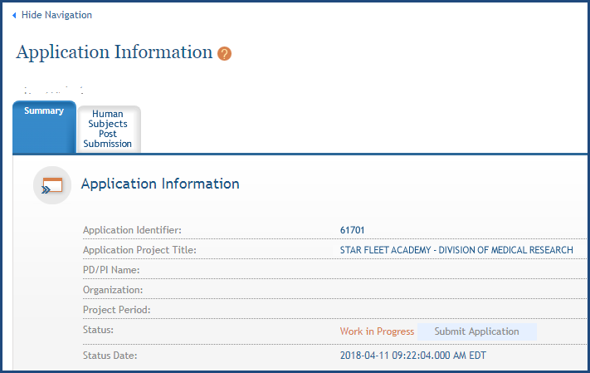  Click on the Human Subjects Post Submission tab. This will take you to a summary page Study Record(s) screen where all study records and delayed onset studies associated with your grant are displayed. Click on the View button in the action column to bring up a particular study.
Reasons to Use
 | Most common use was for updates needed to the RPPR.  - Updates to competing applications  - Updates for reporting purposes  - New IDRs not fully developed at time of application submission | Most common use will be for updates needed to the RPPR.  Pre and post award changes in HSS may include:  - Adding and updating study information  - Updating enrollment data  - Making off-cycle corrections or updates after application or RPPR submission  - Converting a delayed onset study to a full study record, once detailed study info is available  Providing interim data as requested by NIH or required by the FOA or the Terms and Conditions of Award
 | - Update participant and enrollment information  - Provide attributes that further describe the study | - Update participant and enrollment information  - Provide attributes that further describe the study  - Inform NIH of ClinicalTrials.gov registration  - Revise other human subjects related data
Data
 |  | PIs and SOs can update human subjects information in one place
 |  | Application info provided on the PHS Human Subjects and Clinical Trials form automatically populates the Human Subjects System, once a grant number has been assigned*
 | Info was collected at application level | Info collected at study level
 | Foreign and domestic organizations needed to be listed separately on individual Inclusion Data Reports (IDR) | While domestic and foreign organizations still need to be on separate inclusion reports, both inclusion reports can be part of the same study. Concept of network — studies from different sites can be linked to allow one primary project to report study information for other projects working on the same study.
 |  | A new Section 6 – Clinical Trial and Milestone Plan
 | To update the inclusion enrollment data, 'Edit Planned Enrollment’ and 'Edit Cumulative Enrollment' links were available. | To update the human subjects information on a study, including inclusion enrollment data, click the Edit button at the top of the Study Record(s) screen.
 | Entered data manually in table | While data can be updated directly, there is also the ability to upload individual-level data for actual enrollment on sex/gender, race, ethnicity and age of participants in a .csv file  In HSS, there are two ways to edit the existing Inclusion Enrollment Report (IER) data for Cumulative (Actual) counts:  - You can update the cells online in the existing report itself.  - Or you can download a spreadsheet template for entering participant-level data by clicking on the ‘Download Participant Level Data Template’ button.  - Fill the template out with data and then upload the spreadsheet by clicking on the ‘Upload Participant Level Data Attachment’ button. The system will aggregate the uploaded data to populate the cells in the report.  - You can click on the ‘Download Current Participant Level Data’ button to download the file containing the data for your own records.  Note:  - If you plan to upload the Cumulative (Actual) data, you must use the template.  - For the Planned counts, the cells must be updated online in the report itself.
Alignment
 | No alignment with Clinical Trials.gov | Aligns with Clinical Trials.gov  In HSS, grant recipients with clinical trials registered at ClinicalTrials.gov will have the option to add their Clinicaltrials.gov identifier, the NCT number, in Section I of the form following trial registration. Upon entry of the NCT number, users can populate several form fields, including study population characteristics and much of the protocol synopsis, from ClinicalTrials.gov. In the future, users will be able to use data from the Human Subjects System to initiate and populate their ClinicalTrials.gov registration.
Submission
 | Principal investigator could submit, if delegated the right by signing official (SO) | Only SO can submit
 | Studies submitted individually | SO submits all studies at one time
 | PI selected SO from ‘Please select SO for Inclusion emails: Select SO’ link, which routes the IDR to SO | Need not select SO
 | SO received an email, reviewed IDR and submitted IDR by clicking Route to Agency when the status was ‘Pending SO’ | SO submits study by clicking ‘Submit’ button on the Application Information screen (The button becomes active after SO changes status to ‘Ready for Submission’)
Statuses
 | Statuses were not editable by NIH staff | Some statuses (Accepted, Received by Agency) are editable by NIH staff

* This automatic data population occurs only for data submitted on applications with due dates on or after January 25, 2018. This data is then made available to PIs and SOs through eRA Commons.
Note: For applications submitted for due dates before January 25, 2018, only the inclusion enrollment data is populated in the new system.

